**INFOPACK**

**“Playing Together, Living Equality”**

**Youth Exchange**

**PLACE AND DATE: Uri, date:20-26 May 2018**

**PARTICIPANTS:** 30 youngsters aged 18-25 from disadvantaged rural areas (6 per partner country, 3 males and 3 females)

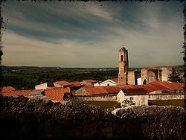

**MAIN OBJECTIVE**

APTSA project aims at fostering a gender-inclusive approach to Sport practices, contrasting sexism and gender stereotypes and promoting equality and mutual respect between genders among young people in disadvantaged rural areas in Europe and in Latin America.

**ACTIVITIES AND METHODS**

Sport activities in combination with NFE methods (Ice-Breaking games, Team Building Activities, Presentations, Outdoor sessions, original NFE Workshops elaborated in project TC Sport Workshops, Roundtables, Debates, Evaluation Groups, Case Studies (simplified), Study Visits, Team-work for the joint elaboration of NFE tools). No specific level of English knowledge will be required to YE participants, therefore the educational programme will be adapted to participants’ learning needs and capacities, giving preference to practical, experiential activities. 1 group leader (youth worker from the sending organization) will support the group, providing translation whenever needed.

**ORGANIZERS AND FACILITATORS**

The main organizers will be the “Youth Division” of Mine Vaganti NGO and the facilitator of the YE will be Vlad Grigoras.



**PARTNERS**

**Italy;** Mine Vaganti NGO

**Bulgaria:** Asociacia Za Razvitie Na Bulgarskia Sport (Bulgarian Sports Development Association)

**Peru:** Brigada de Voluntarios Bolivarianos del Peru

**Brazil:** Associacao Brasileira De Intercambio Cultural (ICYE-Brazil)

**Crotia:** Rijeka Sport’s Association (RSA)

**THE VENUE**

The venue of the Project is Uri, Italian municipality of 3,040 inhabitants famous for its production of artichokes in the province of Sassari. The village’s economy is based on farming, breeding and on craft. The town is located between hills covered with vineyards and olive groves. The village is also located near the artificial lake Cuga.

Uri is located about 18 km from Alghero and about 12 km northwest of Sassari and about 170 kilometers from Cagliari. Province of Sassari is surrounded with famous touristic spots like Alghero, Stintino, Capo Caccia and Castelsardo.

**HOW TO REACH URI?**

Alghero and Olbia have airports which connect North Sardinia with many destinations in Italy and Europe. By boat: the nearest harbours are Porto Torres and Olbia.

For any inquiry, please contact us at following email address: [partenzemine@gmail.com](mailto:partenzemine@gmail.com)

* **HOW TO REACH URI FROM OLBIA AIRPORT?**

-From the airport you can take the bus n.2 or 10 (the bus stop it's just in front of the main Exit on the right side) and get off in the city center of Olbia (ask to get off in Via Mameli);

<http://www.geasar.it/ita/aeroporto/collegamenti-da-per-aeroporto/da-olbia>

<http://www.aspoolbia.it/>

* In the train station, you can take the train to Sassari.

<http://www.trenitalia.com/>

From Sassari bus station you will take a bus from Sassari to Uri.

The bus station is really close to the train station, as you can see in the map.

You can find bus timetable here:

<http://www.arstspa.info/707.pdf>

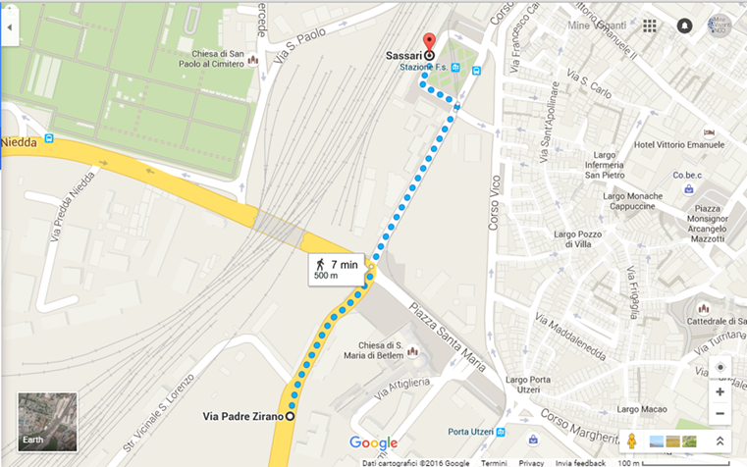

* **HOW TO REACH URI FROM ALGHERO AIRPORT?**

-From the airport you can take the big blue and red bus Arst (the bus stop it's just on the right side of the main Exit ) and get off in Sassari Bus Station (ask to get of in Via padre Zirano);

You can buy the tickets in the airport, or in the bus  
<http://www.aeroportodialghero.it/servizi.asp>

-Once in Sassari, from the same bus station, you should take the bus from Sassari to Uri.

You can buy the tickets in the reselling at the bus station.

You can find bus timetable here:

<http://www.arstspa.info/707.pdf>

**ARRIVAL**

The organization will fix pick up point with the participants and will provide further information about the means of transportation between the airport of Alghero and Olbia and the venue.

If your flight should arrive when it is not possible to utilize the public transport, the host association will hire a means of transport (minibus) which cost (around 15 Euros) is charged on participants.

**RESPONSABILITIES**

Reimbursement of travel costs will only be done upon ***full attendance*** in the training programme (up to 80%) and ***presentation of the original*** ***tickets*** with **BOARDING PASSES and RECEIPT/INVOICES**. Missing tickets will not be reimbursed.

Following the guide lines of the Erasmus + programme the travel must be realized by the participants on direct way within maximum 2 days before or after the project (this days ARE NOT COVERED BY THE PROJECT).

In case of longer stays or indirect travelling (holiday travel etc.) there is no chance of reimbursement of travel costs. Please note if you bought your ticket in your local currency which might be different than EUR, we will calculate your travel costs according to the exchange rates from official European Commission website for the month of ticket purchase

http://ec.europa.eu/budget/inforeuro/index.cfm?Language=en

**CURRENCY** **EXCHANGE**

In Sassari, there is an ATM from which you can withdraw your money.

For those who wish to change their currency into Euros, we suggest to do it in the airport or in the city center of Sassari because **in Uri you have no possibility to do this.**

**Youthpass**

Every participants will receive a Youthpass at the end of the project.

Youthpass is a tool to document and recognise learning outcomes from youth work activities. It is available for projects funded by Erasmus+: Youth in Action (2014-2020) and Youth in Action (2007-2013) programmes. It is a part of the European Commission’s strategy to foster the recognition of non-formal learning, putting policy into practice and practice into policy.

**INTERCULTURAL NIGHT**

The intercultural dimension of any international project it is very important, as it is a great opportunity for you to present your country, traditions and so on, but also your way to be, your lifestyle, your way to communicate, etc.

You can prepare an activity (games, thematic parties,) in which you will present your country, your national food and drinks, dances, etc. (if needed you can use the projector).

Since there is going to be an intercultural night, we ask you to bring something traditional, famous or delicious from home - that you would like to represent your country with, and share with the others, it can be any kinds of food, drink...

**WHAT TO BRING**

What to bring with you?

1) Intercultural night: some yummy food from your countries (candies or salty items) to be share with the rest of the group. Unfortunately you won't be able to cook therefore, please keep in mind to bring with you something already prepared;

2) Medicines and insurance;

3) Original travel e-tickets and invoices like train tickets, boarding passes, bus tickets etc. (fundamental in order to be reimbursed);

4) Your personal belongings (shampoo, shower gel, hairdryer)

5) Bring comfortable shoes, jacket and warm clothes. It will be probably cold!

**WEATHER**

The climate in Uri is warm Mediterranean temperatures characterized by a dry summer season and a rainy season mainly concentrated in autumn and winter months.

It is characterized by extreme temperature changes and rainfall variations.

During February, weather in Uri could be quite cold. So, we suggest to bring jackets and some warm clothes, together with lighter items.

**ACCOMMODATION**

Participants will be accommodated in B&B Alghero, 400 meters far one another. WI – FI connection is not available here.

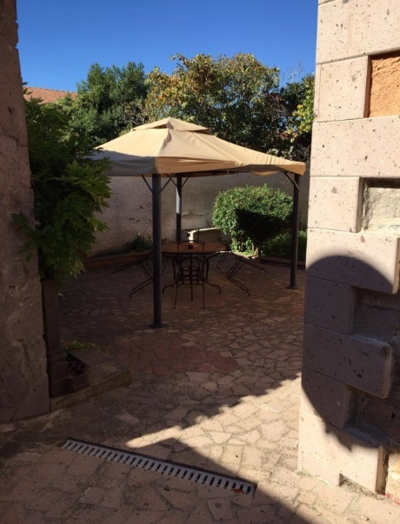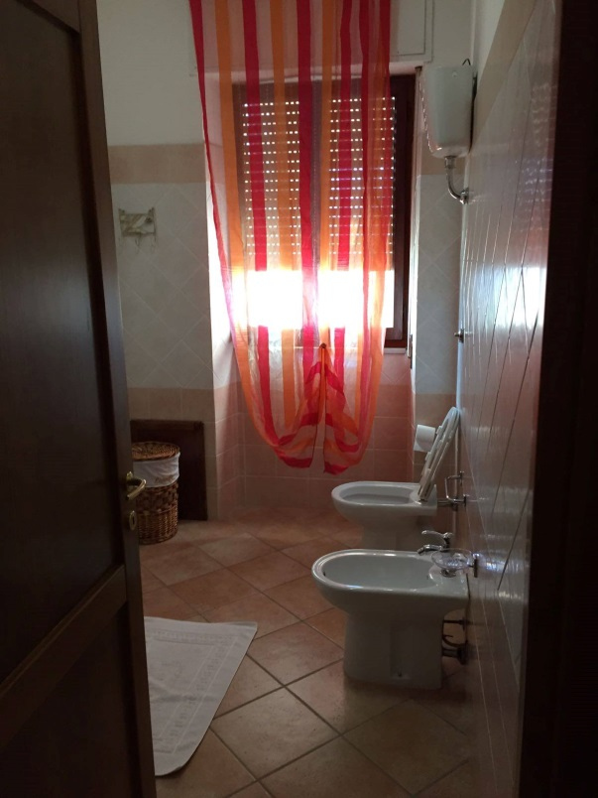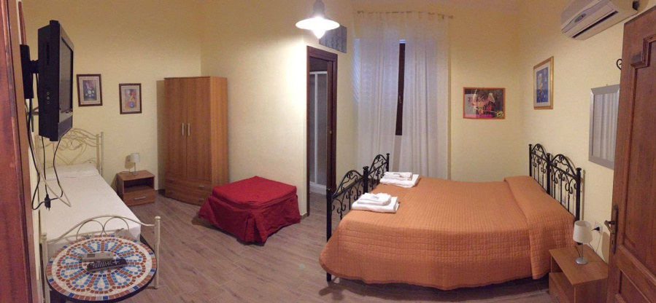

**ACTIVITY ROOM**

The activities will take place in Mine Vaganti NGO’s Office and Youth Centre in Uri, where several Erasmus+ Youth Projects already took place.…And Yes, there is WIFI there!

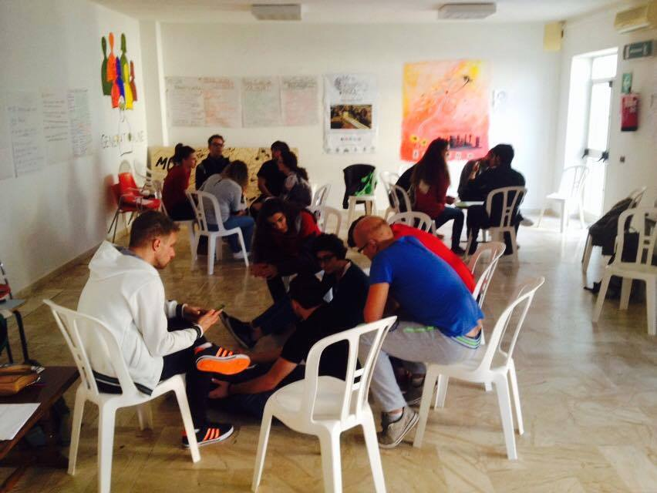

**FOOD**

We will eat at a lot ☺

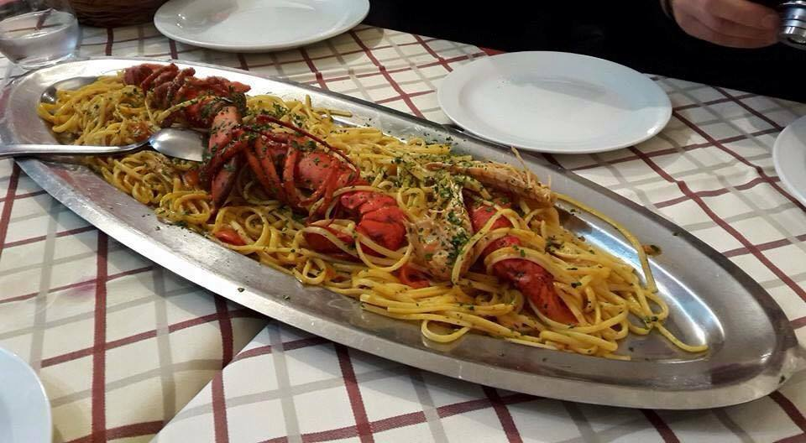

**For further inquire, please contact:**

Maria Grazia Pirina

Vicepresident Mine Vaganti NGO

Phone Number +39340757410 (Whatsapp)

Email: partenzemine@gmail.com

Skype: minevagantingo

